FUNDAMENTALS OF DATA SCIENCE

DATE : 29.08.2024

WORK : UNIT 01, 3.a, 3.b, 3.c

Exp No:3.a Conduct an experiment to show data visualization using line plot

Description: Take any sample data either through csv file or data fetched directly through

code.

CODE:

import matplotlib.pyplot as cricket

Overs=list(range(5,51,5))

Indian_Score=[30,55,90,129,165,200,239,270,310,350]

Srilankan_Score=[25,70,90,120,140,170,195,220,255,279]

cricket.plot(Overs,Indian_Score,label='Indian Score',color='indigo')

cricket.plot(Overs,Srilankan_Score,label='Srilankan Score',color='pink')

cricket.title("Example for line plot")

cricket.xlabel("Overs")

cricket.ylabel("Scores")

cricket.legend()

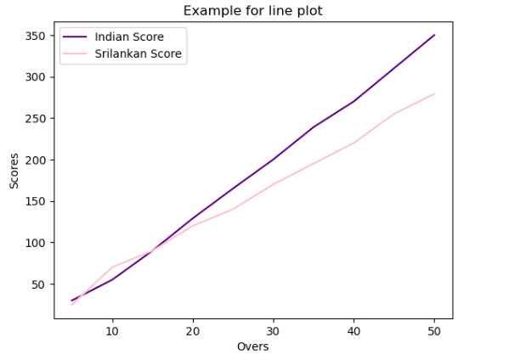

Exp No:3.b Conduct an experiment to show data visualization using bar chart

Description: Take any sample data either through csv file or data fetched directly through

code.

CODE:

import matplotlib.pyplot as hscmark

import numpy as np

Names = ['SHREE', 'DEV', 'KEERTHI','PRIYA','SHAN','KUMARAN']

xaxis = np.arange(len(Names))

Percentage_hsc = [96, 91, 94, 75, 45, 81]

hscmark.bar(Names, Percentage_hsc,color='indigo')

hscmark.xticks(xaxis, Names, rotation=45)

hscmark.xlabel('Names of Pupil')

hscmark.ylabel('Percentage')

hscmark.title('Comparison of HSC Percentage', fontsize=20, color='black')

hscmark.show()

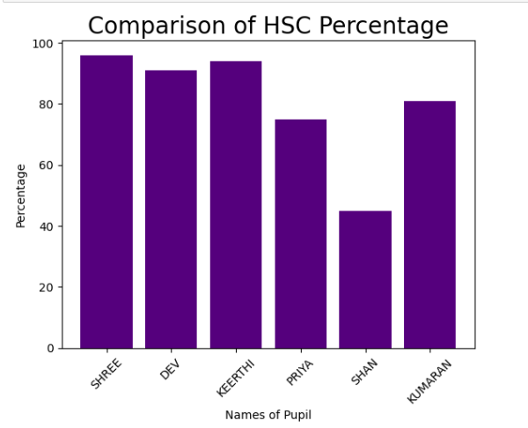

Exp No:3.c Conduct an experiment to show data visualization using pie chart

.Description: Take any sample data either through csv file or data fetched directly through code.

CODE:

import numpy as np

import matplotlib.pyplot as election

roles=['Candidate 1','Candidate 2','Candidate 3','Candidate 4']

count=np.array([100,65,23,10])

colours = ['red','blue','green','yellow']

election.pie(count,labels=roles,colors=colours)

election.legend(loc="upper left",bbox_to_anchor=(1,1))

election.title("Example for Pie chart")

election.show()

